ADDRESS | AMOUNT | AVAILABILITY | VIEW / PHOTO LINK | CONTACT INFORMATION | HOUSING VOUCHERS / SECTION 8 | DESCRIPTION
PASSAIC COUNTY
377 Madison St Unit 10  Passaic, NJ 07055 | $1,545/mo  1 bd, 1 ba  700 sq ft | NOW | 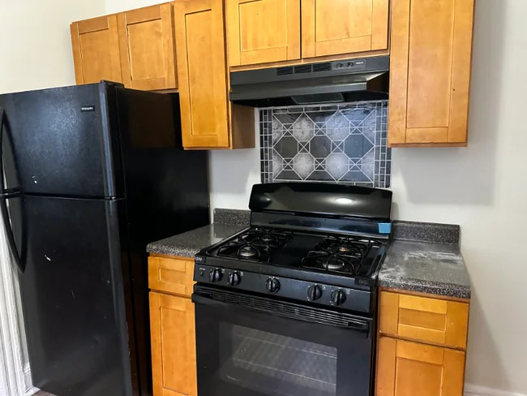 | John Stevenson  eRealty Advisors, Inc.  862-304-5255 | Not stated - verify before applying | Remodeled one-bedroom, one-bath Passaic apartment with living room and eat-in kitchen. Public listing details describe fresh paint, heat and hot water included, a third-floor location across from Christopher Columbus Park, and a location minutes from downtown Passaic. Amenities noted include refrigerator, oven, freezer, tile floors, intercom, security system, and included water, trash removal, and sewer. Confirm deposit, application requirements, fees, lease terms, and voucher policy before applying.
551 Summer St Unit 2R  Paterson, NJ 07501 | $1,475/mo  2 bd, 1 ba | NOW | 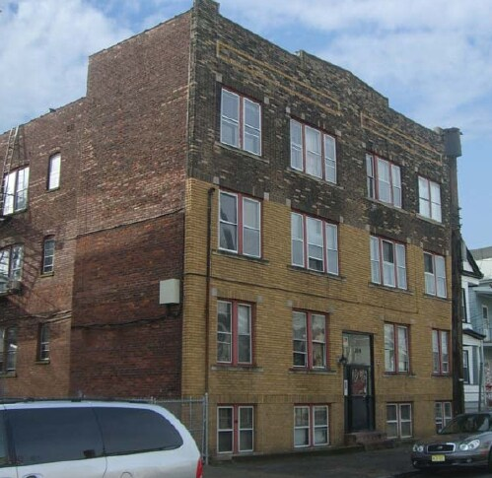 | 551 Summer St Leasing  862-310-6309 | Not stated - verify before applying | Two-bedroom, one-bath Paterson apartment listed within the requested rent range. Confirm exact floor, room sizes, included utilities, parking access, lease term, security deposit, required fees, inspection issues, and Housing Choice Voucher policy before applying.
148 Clinton St Unit 2  Paterson, NJ 07522 | $1,475/mo  1 bd, 1 ba | NOW | 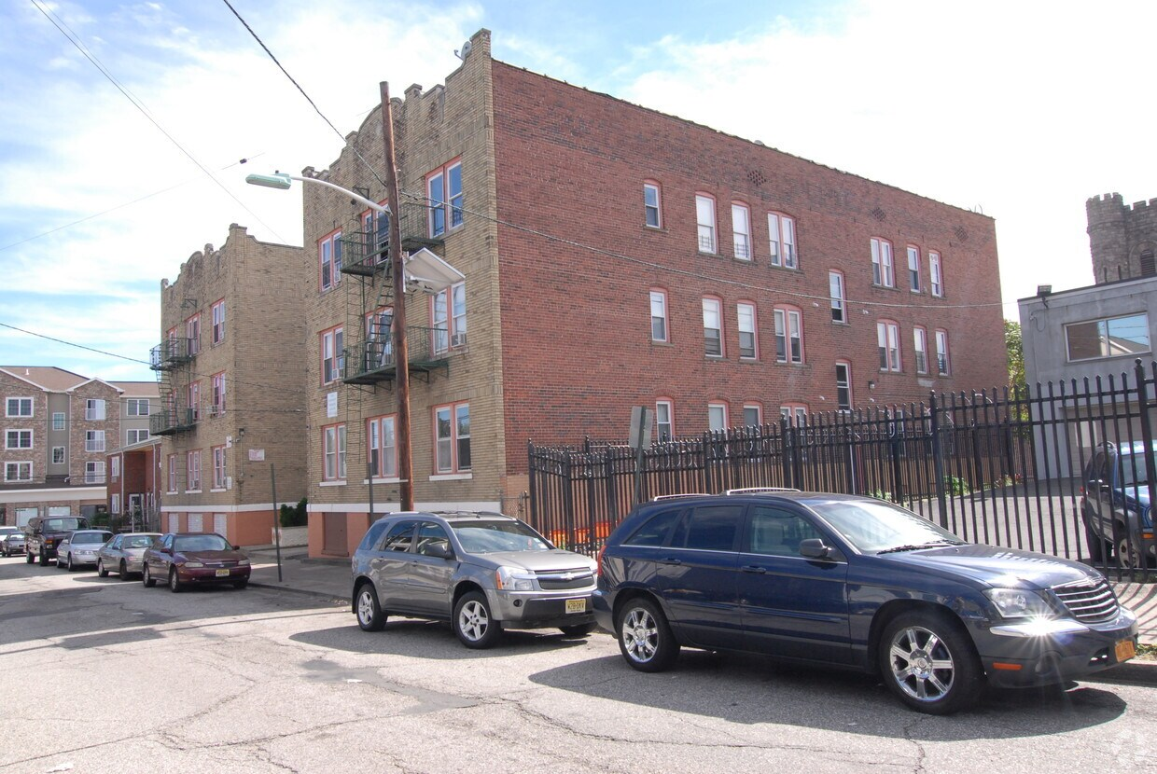 | 148 Clinton St Leasing  862-319-3466 | Not stated - verify before applying | One-bedroom, one-bath Paterson apartment listed at $1,475. Applicant should confirm unit condition, floor level, appliance details, included utilities, parking, move-in charges, application requirements, and voucher policy directly with the leasing contact before submitting documents or payment.
154 Hamilton Ave Unit 202  Paterson, NJ 07501 | $1,450/mo  Studio, 1 ba | NOW | 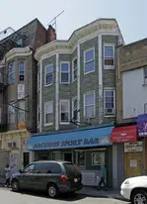 | 154 Hamilton Ave Leasing  862-319-8366 | Not stated - verify before applying | Studio, one-bath apartment in Paterson listed within the requested rent range. Confirm the exact available unit, building access, kitchen appliances, laundry options, utility responsibility, security deposit, lease term, parking, and voucher policy before applying.
100 Rosa Parks Blvd Unit B1B  Paterson, NJ 07501 | $1,500/mo  1 bd, 1 ba | NOW | 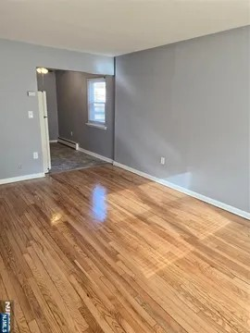 | 100 Rosa Parks Blvd Leasing  201-467-9294 | Not stated - verify before applying | One-bedroom, one-bath Paterson apartment listed at $1,500. Confirm current move-in readiness, building rules, security deposit, utility responsibility, parking, application requirements, lease term, and Housing Choice Voucher policy before applying.
54 Center St  Clifton, NJ 07011 | $1,300/mo  1 bd, 1 ba | NOW | 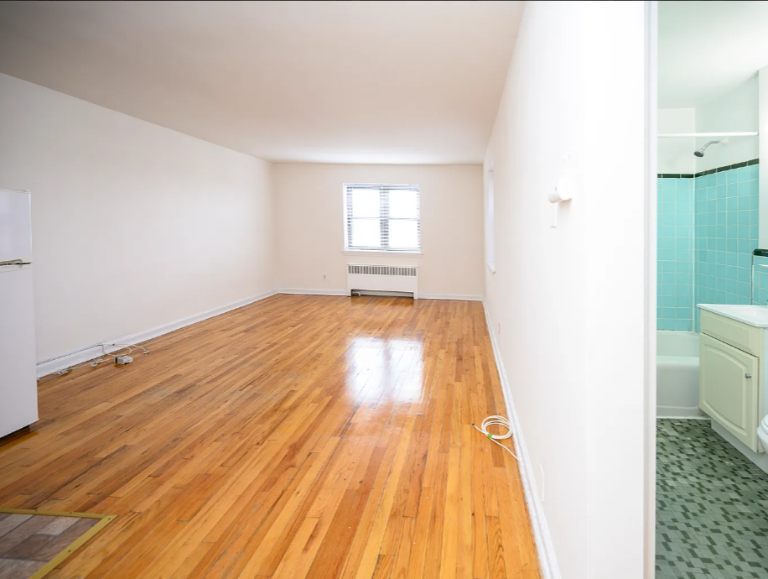 | 54 Center St Leasing  973-686-1500 | Not stated - verify before applying | One-bedroom, one-bath Clifton apartment listed within the requested rent range. Applicant should confirm unit layout, included appliances, utilities, parking, laundry access, required fees, security deposit, move-in timing, and voucher policy before applying.
ESSEX COUNTY
61 S Munn Ave Unit 104  East Orange, NJ 07018 | $1,395/mo  Studio, 1 ba | NOW | 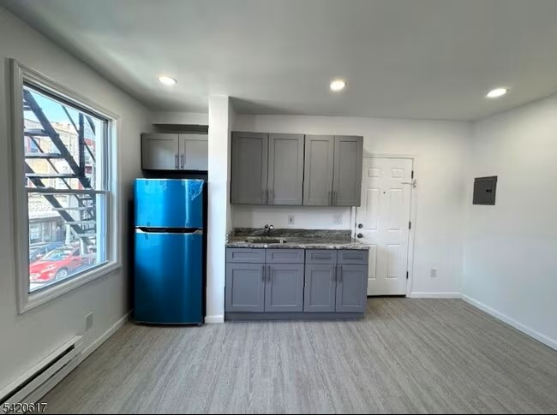 | 61 S Munn Ave Leasing  862-418-1136 | Not stated - verify before applying | Studio, one-bath East Orange apartment listed within the requested rent range. Confirm exact unit condition, square footage, heating/cooling, appliances, laundry access, parking, deposits, fees, lease term, and voucher policy before applying.
18 Summit St  East Orange, NJ 07017 | $1,200/mo  1 bd, 1 ba | NOW | 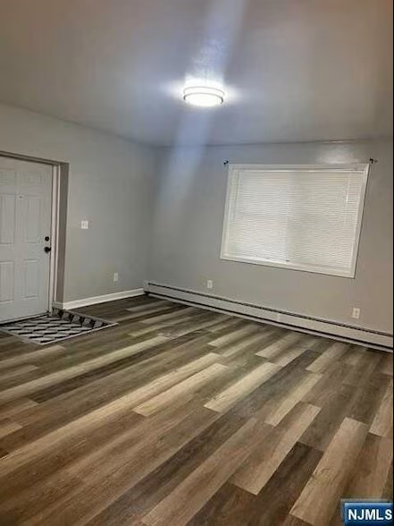 | 18 Summit St Leasing  862-322-6741 | Not stated - verify before applying | Renovated East Orange apartment option listed within the requested rent range. Listing information identifies updated interior features and current rental availability. Confirm exact unit number, utilities, move-in costs, application requirements, parking, laundry, and voucher policy before applying.
273 S Orange Ave Unit 273D  Newark, NJ 07103 | $1,225/mo  Studio, 1 ba | NOW | 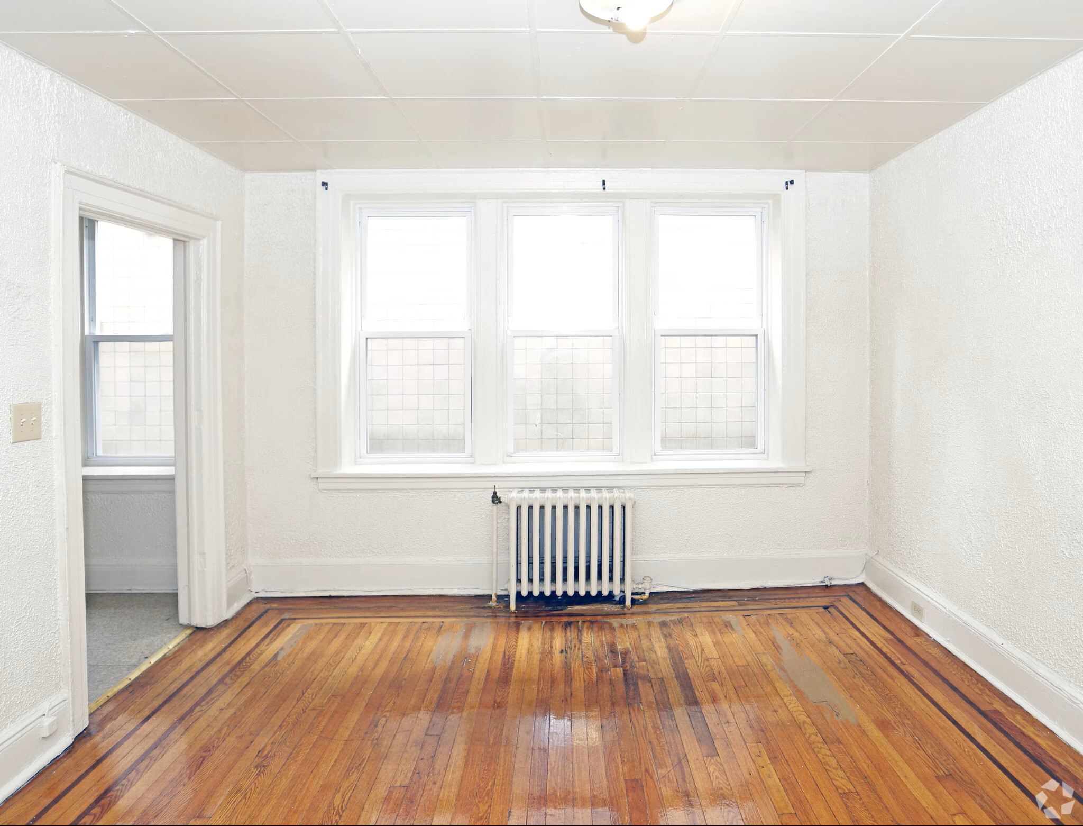 | 273 S Orange Ave Leasing  973-318-3497 | Not stated - verify before applying | Studio, one-bath Newark apartment listed at $1,225. Public details note proximity to public transportation and small stores, with parking available on premises or through free street parking. Confirm final move-in readiness, included utilities, security deposit, lease term, fees, and voucher policy before applying.
94 Fairmount Terrace Unit 412  East Orange, NJ 07018 | $1,500/mo  1 bd, 1 ba | NOW | 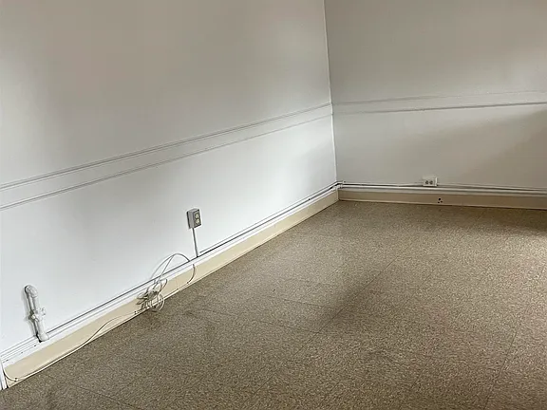 | 94 Fairmount Terrace Leasing  862-386-2983 | Not stated - verify before applying | One-bedroom, one-bath East Orange apartment listed within the requested rent range. Applicant should confirm elevator/building access if applicable, floor level, utility responsibility, laundry, parking, deposit requirements, lease term, and Housing Choice Voucher policy before applying.
125 Osborne Terrace Unit 14  Newark, NJ 07108 | $1,500/mo  1 bd, 1 ba | NOW | 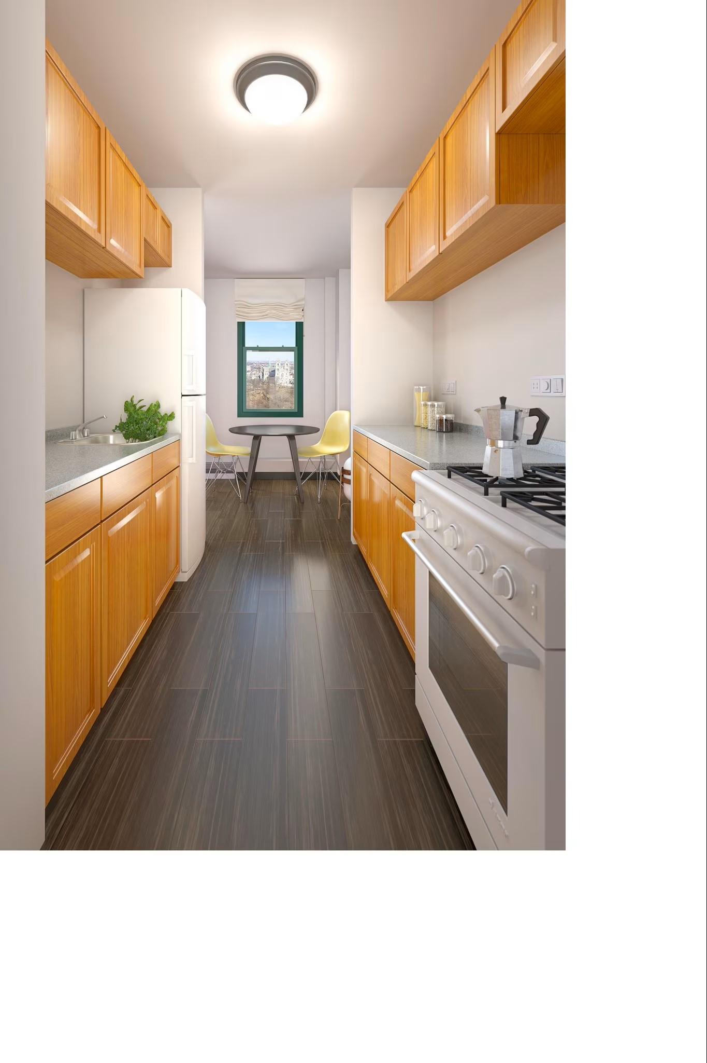 | 125 Osborne Terrace Leasing  732-795-5397 | Not stated - verify before applying | One-bedroom, one-bath Newark apartment listed at $1,500. Confirm the exact unit, current interior condition, appliances, utilities, parking, application requirements, security deposit, move-in costs, lease term, and voucher policy before applying.
12 Elmwood Ave Unit BL 1  Bloomfield, NJ 07003 | $1,300/mo  1 bd, 1 ba | NOW | 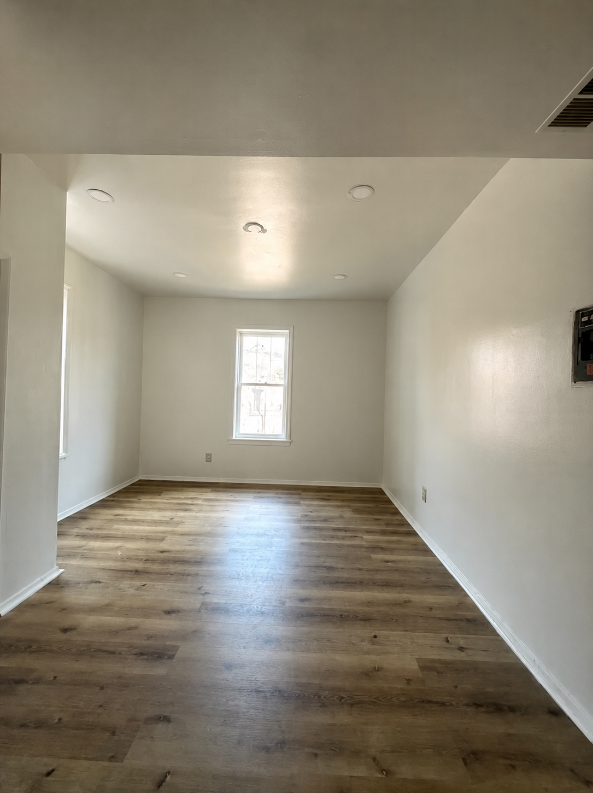 | 12 Elmwood Ave Leasing  848-800-2391 | Not stated - verify before applying | Bloomfield apartment option listed within the requested rent range. Public listing information describes an eat-in kitchen with stove and refrigerator, heat and hot water, hardwood floors, coin laundry, street parking, and access near transportation/train service. Confirm exact unit, deposits, fees, and voucher policy before applying.
UNION COUNTY
231 Ripley Pl Unit 4  Elizabeth, NJ 07206 | $1,400/mo  1 bd, 1 ba | Available Aug 15 | 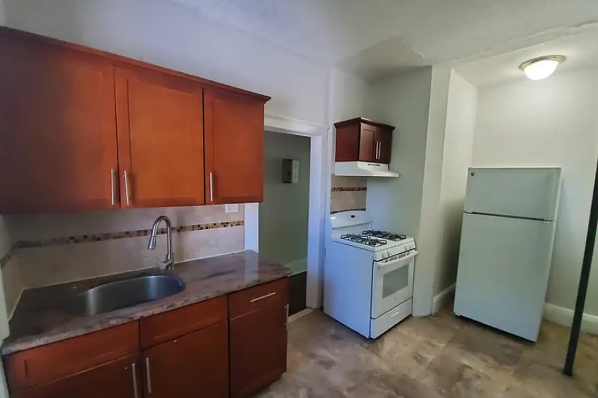 | Chad H  908-266-6581 | Not stated - verify before applying | One-bedroom, one-bath Elizabeth apartment listed at $1,400. Listing details state the owner pays heat, hot water, gas, and electric, with oven, refrigerator, tile floors, and utilities included. Confirm total move-in cost, income requirements, occupancy limits, application requirements, and voucher policy before applying.  Pet policy: No pets allowed.
Sheridan Gardens  1093 Sheridan Ave, Elizabeth, NJ 07208 | $1,400/mo  Studio, 1 ba | NOW | 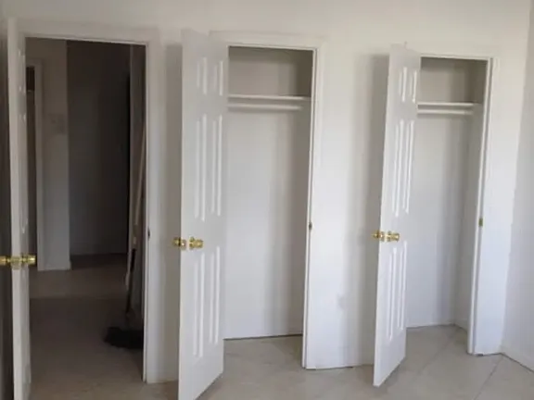 | Sheridan Gardens Leasing  908-739-6919 | Not stated - verify before applying | Studio apartment option at an Elizabeth apartment community listed within the requested rent range. Confirm exact available unit, included heat/water/trash if applicable, parking, laundry, deposits, fees, lease term, move-in timing, and voucher policy before applying.
516 E Jersey St Unit 3  Elizabeth, NJ 07206 | $1,500/mo  2 bd, 1 ba  750 sq ft | NOW | 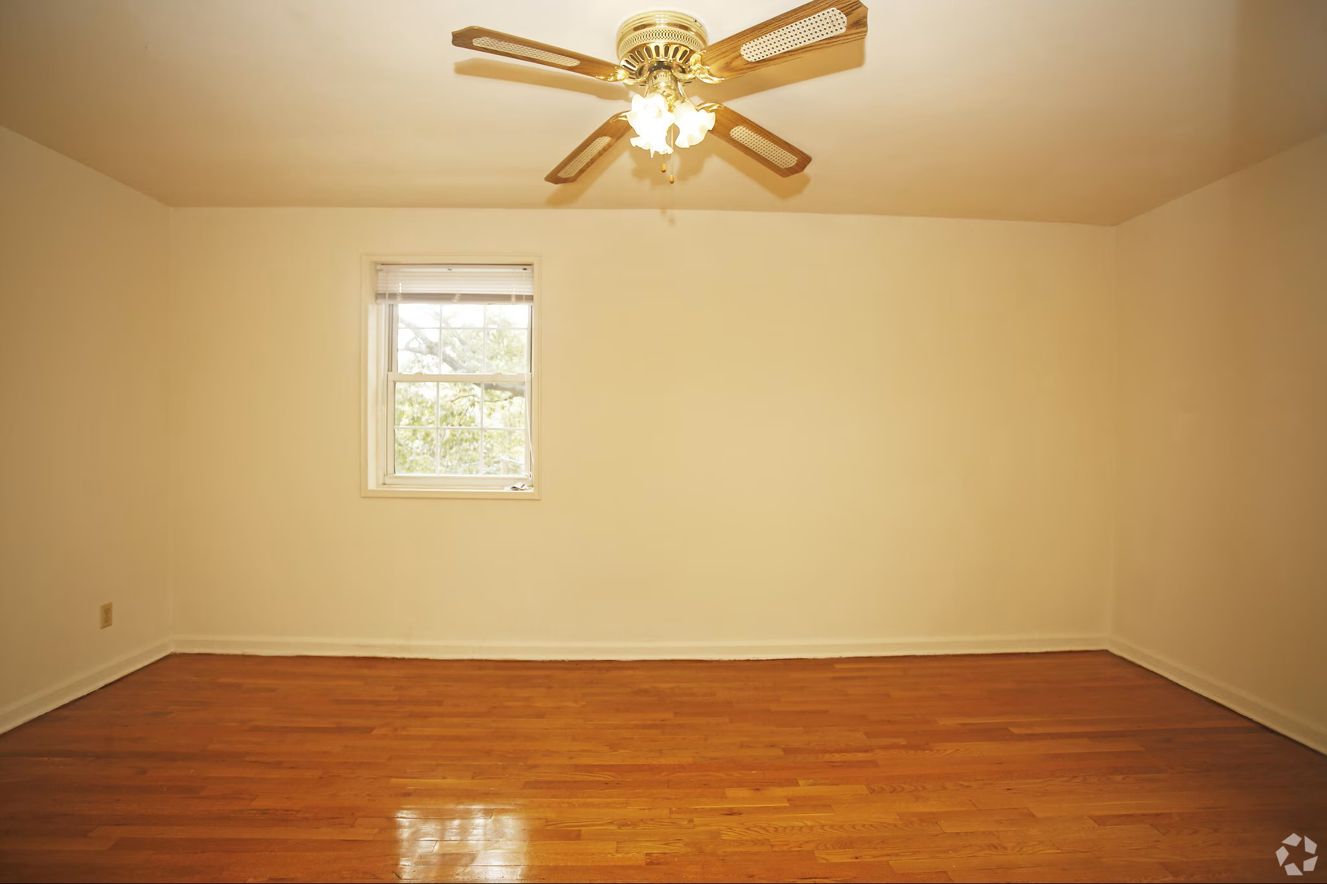 | 516 E Jersey St Leasing  908-965-8340 | Not stated - verify before applying | Two-bedroom, one-bath Elizabeth apartment listed at $1,500. Public details describe a well-maintained, move-in-ready unit with bright functional layout, modern flooring, natural light, updated bathroom, spacious bedrooms, cozy living area, and location near shopping, dining, public transit, and major highways. Confirm deposit, fees, lease term, and voucher policy before applying.  Pet policy: No pets allowed.
Westminster Towers Apartments  801 N Broad St, Elizabeth, NJ 07208 | $1,400/mo  Studio | NOW | 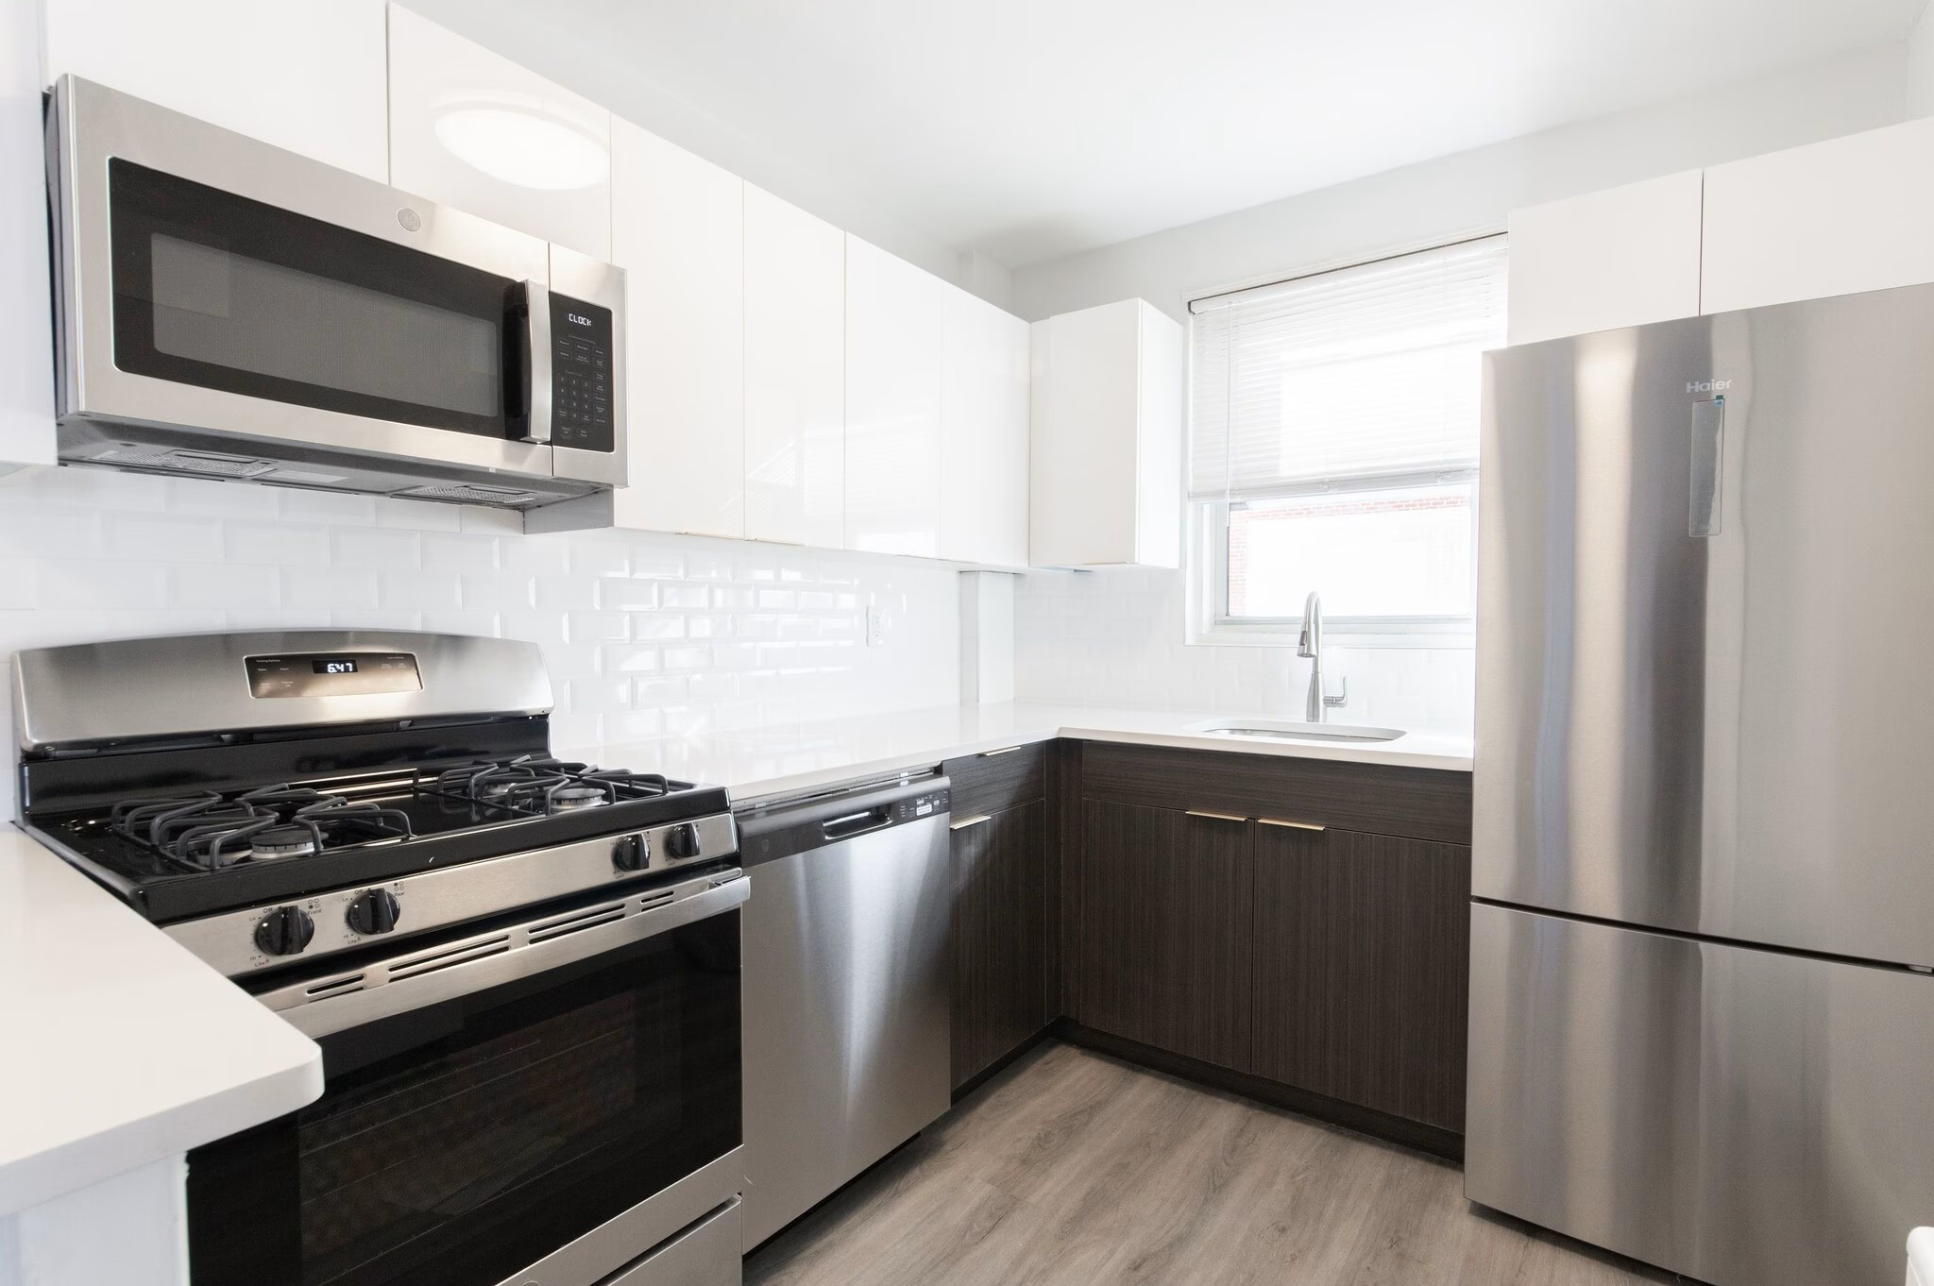 | Westminster Towers Apartments Leasing  908-738-9911 | Not stated - verify before applying | Studio apartment option at an Elizabeth apartment community listed within the requested rent range. Public property information describes a well-situated community, prompt assistance, emergency maintenance, and on-site support. Confirm exact unit, utilities, deposits, income/credit requirements, parking, and voucher policy before applying.
Wood Arms Apartments  30 E Elm St, Linden, NJ 07036 | $1,450+/mo  Studio | NOW | 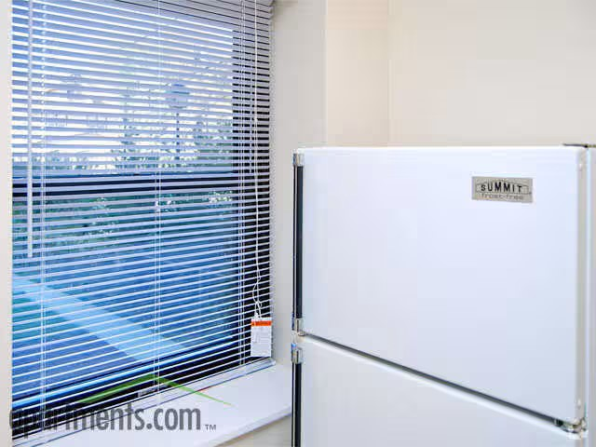 | Wood Arms Apartments Leasing  908-663-1872 | Not stated - verify before applying | Studio apartment option in Linden listed within the requested rent range. Public information describes apartment homes designed for natural light and views, with nearby shopping centers, public transit access, recreational options, and convenient regional travel access. Confirm exact floor plan, deposits, fees, utilities, laundry, parking, and voucher policy before applying.
Portside II  136 Pine St, Elizabeth, NJ 07206 | $1,017/mo 1 bd  $1,209+/mo 2 bd  $1,397+/mo 3 bd | NOW | 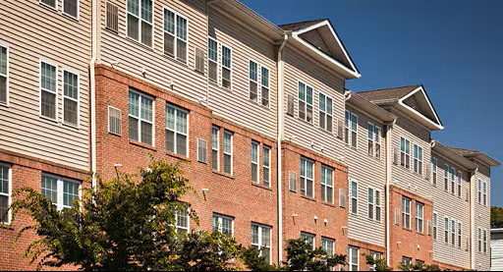 | Portside II Leasing  201-423-6440 | YES - income-restricted community; verify voucher eligibility | Elizabeth apartment community with one-, two-, and three-bedroom price options shown within the requested range. Confirm current unit availability, household-size rules, income qualifications, utility allowances, deposits, waitlist status, and Housing Choice Voucher compatibility before applying.

SOURCE AND VERIFICATION NOTES
• This listing is a community resource document, not a guarantee that a unit is still available.
• Prices, fees, availability, deposits, utilities, pet policies, income requirements, and Housing Choice Voucher acceptance can change without notice.
• Housing voucher status is marked YES only where a public listing or voucher-specific rental source explicitly indicated Section 8 / voucher-related availability; otherwise, verify before applying.

